# **Insights into the Online Retail Dataset**

Datasets name: Online Retail Dataset

Description: Exploring E-commerce Transactions and Customer Behavior.

This Online Retail Dataset contains records about retail transactions conducted online. It includes information about customer purchases, such as the invoice number, stock code, description of items purchased, quantity, unit price, invoice date, customer ID, and country. You can access the dataset [here](https://t.co/Kf9GvpRRNh) and its analysis [here](https://github.com/HenryMorganDibie/Online-Retail/tree/main).

1. **How do discounts or promotions affect customer buying behavior, and what strategies could be implemented to optimize pricing and maximize revenue?**

* Impact of Promotions: The analysis compares total sales during promotional and non-promotional periods, showing the effectiveness of promotions in stimulating purchasing behavior.
* Customer Response to Promotions: It identifies the number of customers responding to promotions, aiding in tailoring promotional strategies.
* Revenue Metrics: Total revenue and average order value metrics provide insights into overall revenue performance and pricing strategies.
* Optimization Strategies: Suggestions for dynamic pricing based on demand and customer segments aim to maximize revenue.

**Key Metrics:**

* Total sales during promotional periods: $5,427,828.57
* Total sales during non-promotional periods: $4,319,919.36
* Percentage increase in sales due to promotions: Approximately 25.65%
* Number of customers responding to promotions: 4,268
* Total revenue: $9,747,747.93
* Average order value: $376.36

1. **Can you identify any outliers or anomalies in the dataset, such as unusually large orders or frequent returns, and what factors might explain them?**

* Customer Profiles: Customers associated with anomalies exhibit higher total sales and order counts, suggesting personalized discounts or incentives as retention strategies.
* Review and Refund Management: Reviewing product descriptions and feedback can address negative total sales, while robust refund and return processes manage negative sales effectively.

**Summary Statistics:**

* 1,873 unique customer IDs associated with anomalies.
* Average total sales: £4,289.70; Average orders: 10.69.
* Standard deviation of total sales: High.
* Minimum total sales: Negative (£4,287.63); Maximum total sales: £1,447,682.00.
* Median total sales: £1,414.99.

1. **What is the month-over-month or year-over-year growth rate in revenue for each product category, and how does it compare to overall revenue growth?**

* Monthly Revenue Growth Rates by Category: Breaks down revenue growth rates for each product category monthly, comparing month-over-month and year-over-year rates.
* Overall Monthly Revenue Growth Rate: Calculates overall monthly revenue growth rate, providing a comparison against individual categories.
* Overall Yearly Revenue Growth Rate: Includes an overall yearly revenue growth rate for a broader perspective.

**Revenue Growth Rates:**

* Decor, Lighting, Other Categories: Month-over-month growth rates range from -0.70% to 0.91%.
* Overall Monthly Revenue: Ranges from -0.70% to 0.49%.
* Overall Yearly Revenue (December 2011): -0.42%.

1. **Can you create a geographical heat map showing the distribution of customer orders by country, and identify any region with particularly high or low sales activity?**

* Geographical Heatmap: Displays order distribution by country, highlighting regions with high or low sales activity.

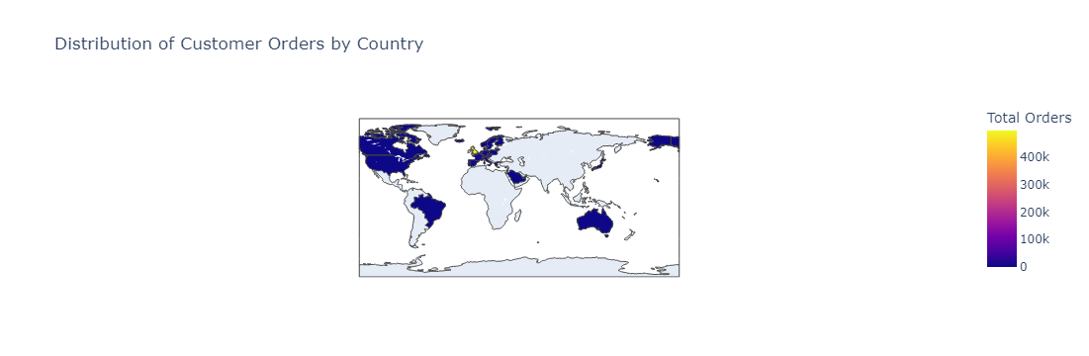

1. **How does customer satisfaction, as measured by ratings or feedback, correlate with repeat purchase behavior or customer lifetime value, and what insights can be gained to improve customer experience and retention strategies?**

* Correlation Analysis: Little to no correlation between customer satisfaction and repeat purchase behavior, suggesting other factors drive repeat purchases.

1. **Can you identify any seasonal trends or patterns in customer purchasing behavior based on the invoice dates?**

* Seasonal Trends: Observes increase in sales volume towards year-end, particularly in November, followed by a decrease in December. Variability in December sales indicates higher purchasing activities during the holiday season.